**TIPS -Aishwarya Annel -11178-AI PROJECT**

# PROMPTS AND SCREENSHOTS OF OUTPUT

You are a data science expert. Being a beginner, I want responses for the below questions with Python code along with it. Attaching the tips Excel sheet.

1. Provide me basic statistics of 5 important columns like 1. mean 2. median 3. mode 4. std dev 5. min 6. max based on the above attached file with Python code

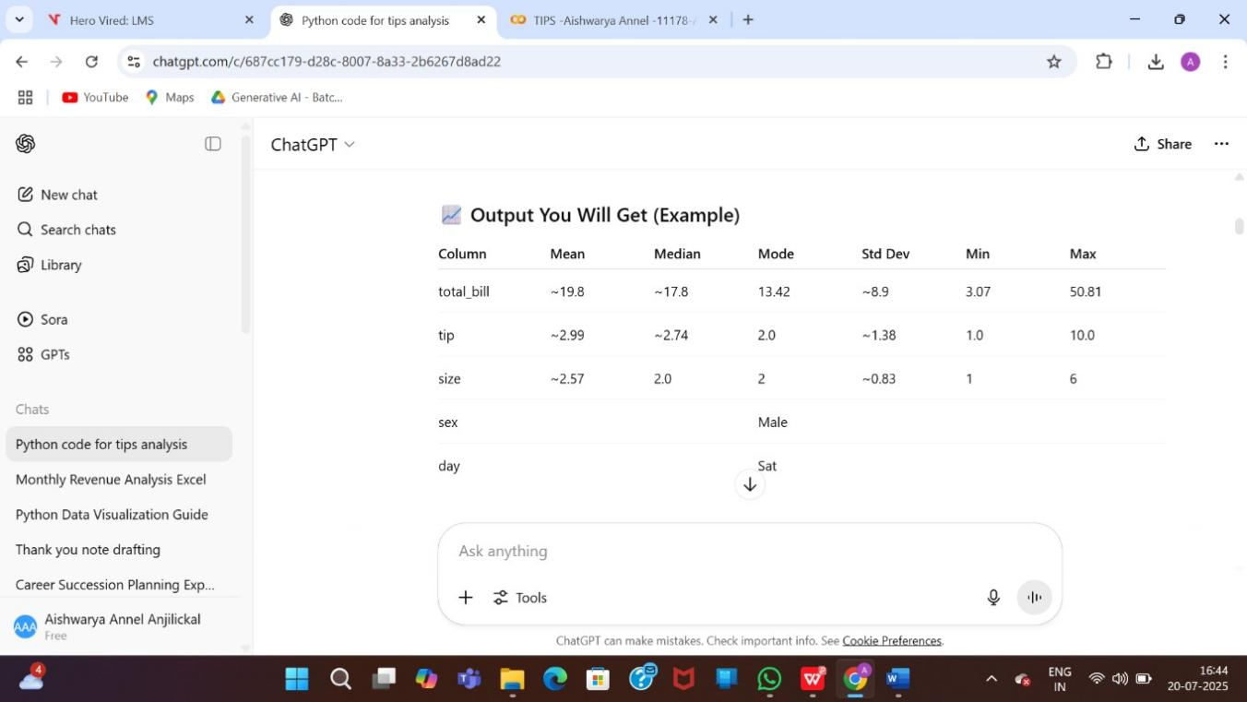

1. I am using google collab. provide me the code for uploading file into google collab

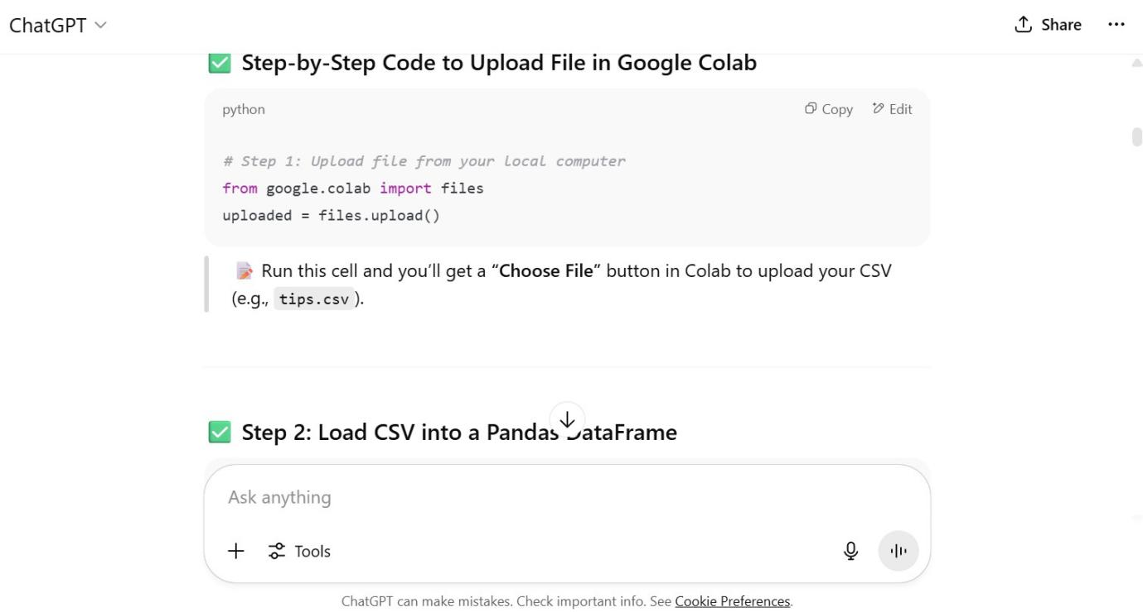

1. Provide me response and Python code to check for missing values and outliers in the attached file. I am using Google Colab.

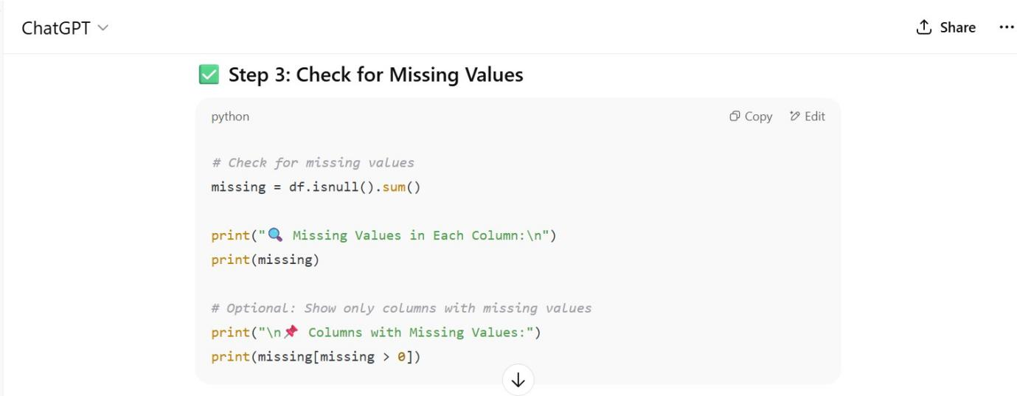

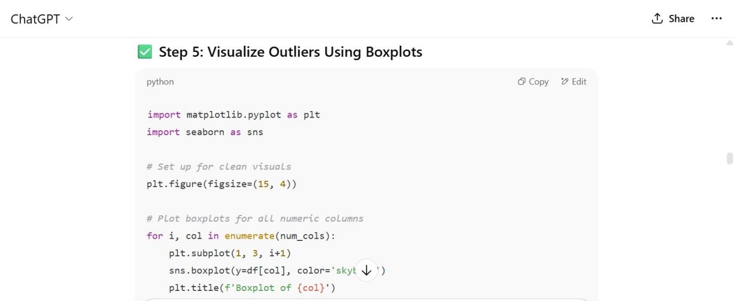

1. Provide responses and Python code for univariate analysis for above above-attached file. I am using Google Colab. recommend me the best tools for univariate analysis.

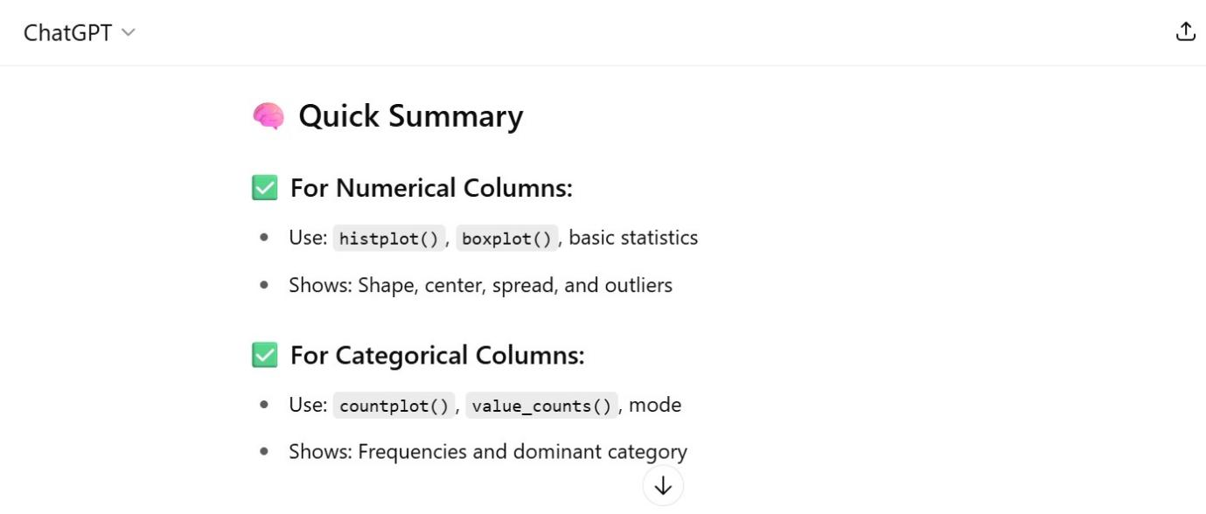

1. Provide responses and Python code for the Bivariate analysis for above above-attached file. I am using Google Colab. recommend me the best tools for Bivariate analysis.

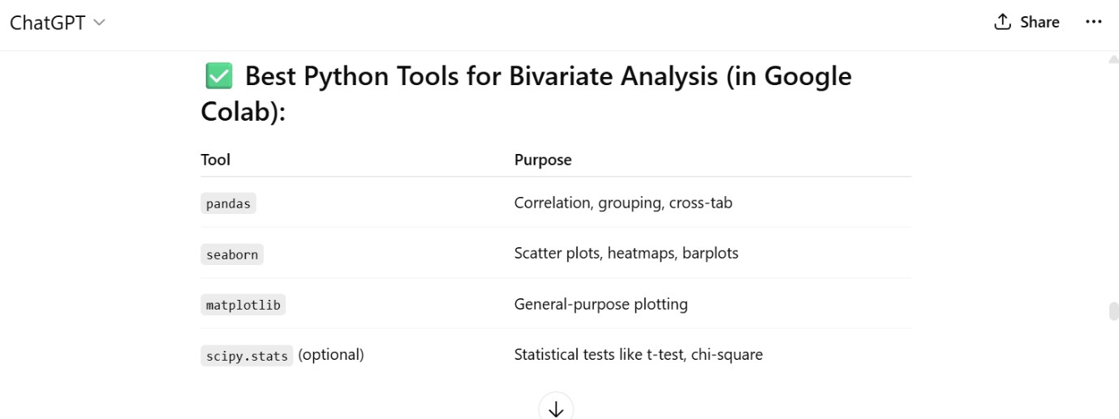

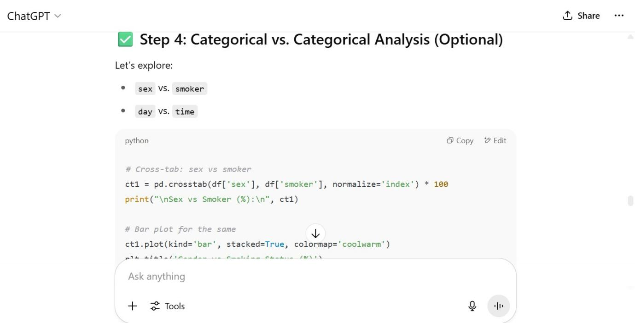

Provide me visualization of univariate and bivariate analysis, check for missing files and outliers of above attached file. provide visualization in Microsoft Excel, being an Excel expert

Create and share a downloadable .xlsx file with all stats and visualizations, dashboards, and charts.

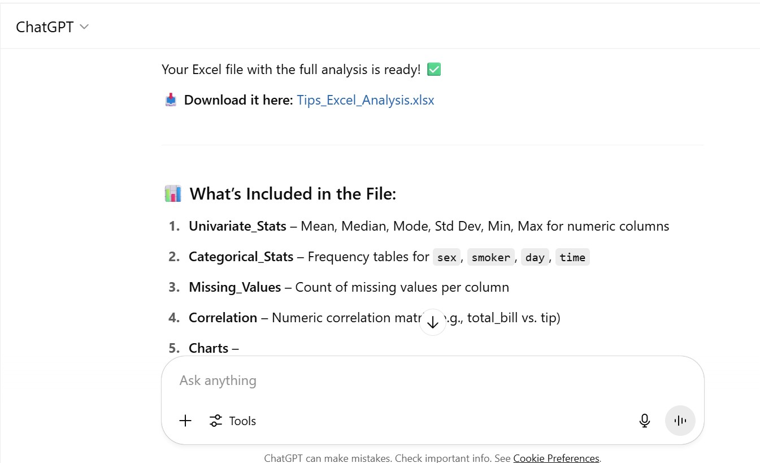

Export as pdf report

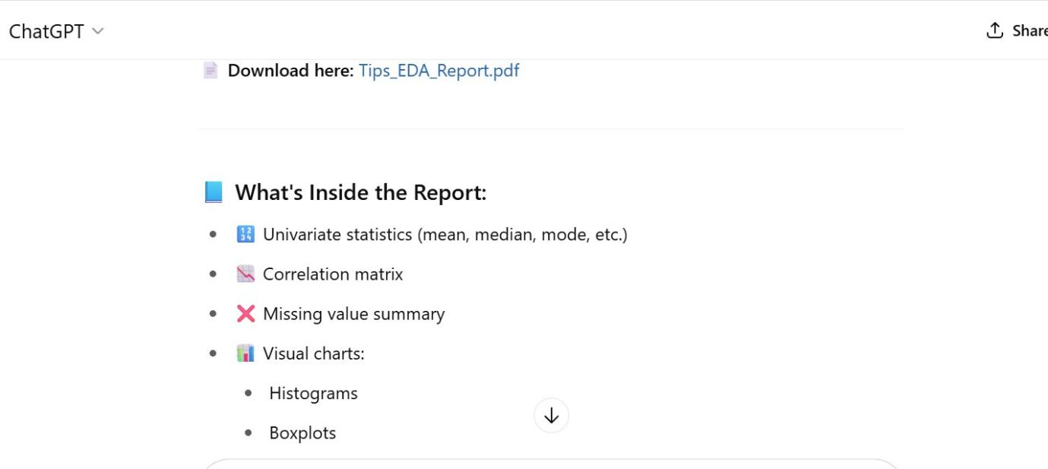

# LINK OF COLLAB NOTEPAD

<https://colab.research.google.com/drive/1cPUhE5b7EalSxR7_Y7PIpGsQeGKztbJf?usp=sharing>